Part B
16 Explain JVM in brief?
Bytecode :-
- A special machine language that can be understood by the Java Virtual Machine (JVM)
- independent of any particular computer hardware, so any computer with a Java interpreter can execute the compiled Java program, no matter what type of computer the program was compiled on .
Java Virtual Machine (JVM):-
- All languages compiler translate source code into machine code for a specific computer. Java compiler also does the same thing. Then how does java achieve architecture neutrality? The answer is that the java compiler produces an intermediate code known as bytecode for machine does not exist. this so called virtual machine is known as the java virtual machine (JVM) & it exists only inside the computer memory. The machine language for the java virtual machine is called java bytecode.
- The process of compiling a java program into bytecode which is also referred to as virtual machine code is not machine specific. The machine specific code generated by the java interpreter by acting as intermediary between the virtual machine & the real machine as given in following fig. the interpreter is different for different machine.
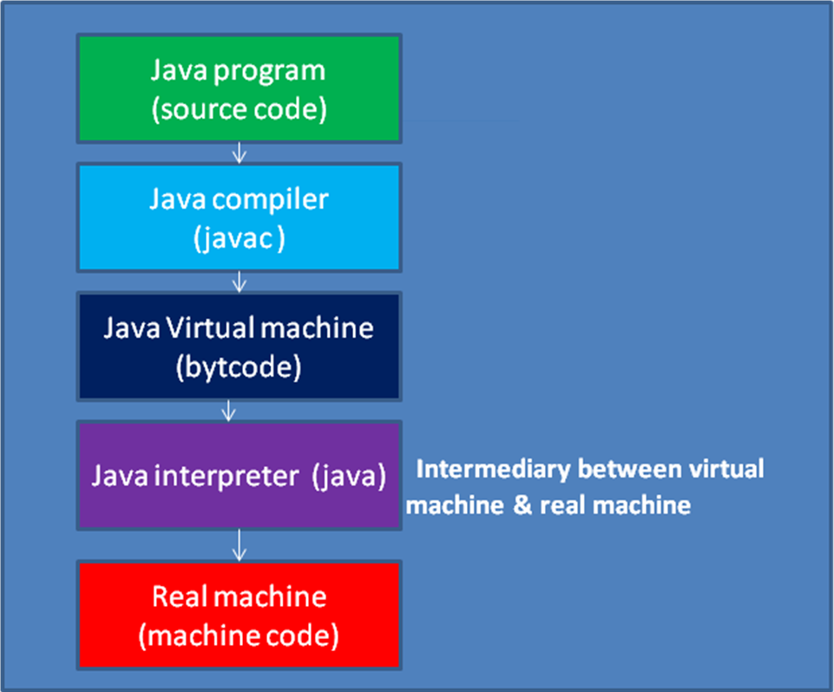
Fig:- process of compilation & converting bytecode into machine code
- Java bytecode run on any computer that has an interpreter this is one of the essential features
of java: the same compiled program can be run on many different types of computer.

 | Java program →compiler →java bytecode program | Java interpreter for Mac os
 | Java program →compiler →java bytecode program | Java interpreter for windows
 | Java program →compiler →java bytecode program | Java interpreter for Linux
Fig: java compiler & interpreter
Note :only for reference
A Java Virtual Machine (JVM) is a set of computer software programs and data structures that use a virtual machine model for the execution of other computer programs and scripts. The model used by a JVM accepts a form of computer intermediate language commonly referred to as Java bytecode. This language conceptually represents the instruction set of a stack-oriented, capability architecture. As of 2006, there are an estimated four billion JVM-enabled devices worldwide.
Overview:
Java Virtual Machines operate on Java bytecode, which is normally (but not necessarily) generated from Java source code; a JVM can also be used to implement programming languages other than Java. For example, a source code can be compiled to Java bytecode, which may then be executed by a JVM. JVMs can also be released by other companies besides Sun (the developer of Java) — JVMs using the "Java" trademark may be developed by other companies as long as they adhere to the JVM specification published by Sun (and related contractual obligations).
The JVM is a crucial component of the Java Platform. Because JVMs are available for many hardware and software platforms, Java can be both middleware and a platform in its own right — hence the trademark write once, run anywhere. The use of the same bytecode for all platforms allows Java to be described as "compile once, run anywhere", as opposed to "write once, compile anywhere", which describes cross-platform compiled languages. The JVM also enables such features as Automated Exception Handling that provides 'root-cause' debugging information for every software error (exception) independent of the source code.
The JVM is distributed along with a set of standard class libraries that implement the
Java API (Application Programming Interface). An application programming interface is what a computer system, library or application provides in order to allow data exchange between them. They are bundled together as the Java Runtime Environment.
Execution environment:-
Programs intended to run on a JVM must be compiled into a standardized portable binary format, which typically comes in the form of .class files. A program may consist of many classes in different files. For easier distribution of large programs, multiple class files may be packaged together in
a .jar file (short for Java archive).
The JVM runtime executes .class or .jar files, emulating the JVM instruction set by interpreting it, or using a just-in-time compiler (JIT) such as Sun's Hotspot. JIT compiling, not interpreting, is used in most JVMs today to achieve greater speed. Ahead-of-time compilers that enable the developer to precompile class files into native code for a particular platforms also exist.
Like most virtual machines, the Java Virtual Machine has a stack-based architecture akin to a microcontroller/microprocessor.
The JVM, which is the instance of the JRE (Java Runtime Environment), comes into action when a Java program is executed. When execution is complete, this instance is garbage-collected. JIT is the part of the JVM that is used to speed up the execution time. JIT compiles parts of the byte code that
have similar functionality at the same time, and hence reduces the amount of time needed for compilation.
Bytecode verifier:-
-tests the format of the code fragments and checks the code fragments for illegal code that can violate access rights to object
JIT:
Although Java was designed for interpretation, there is technically nothing about Java that prevents on-the-fly compilation of bytecode into native code. Along these lines, Sun supplies its Just In Time (JIT) compiler for bytecode, which is included in the Java 2 release. When the JIT compiler is part of the JVM, it compiles bytecode into executable code in real time, on a piece-by-piece, demand basis. It is important to understand that it is not possible to compile an entire Java program into executable
code all at once, because Java performs various run-time checks that can be done only at run time. Instead, the JIT compiles code as it is needed, during execution. However, the just-in-time approach still yields a significant performance boost. Even when dynamic compilation is applied to bytecode, the portability and safety features still apply, because the run-time system (which performs the compilation) still is in charge of the execution environment. Whether your Java program is actually interpreted in the traditional way or compiled on-the-fly, its functionality is the same.

17 Explain the Structure of Java? Explain type of programs in Java.

The Basic Structure of a Simple Java program
A Java program consists of different sections. Some of them are mandatory but some are optional. The optional section can be excluded from the program depending upon the requirements of the programmer.
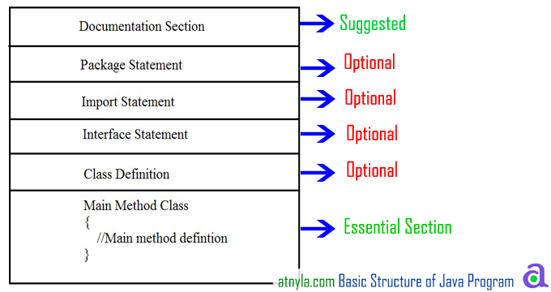

Documentation Section
It includes the comments that improve the readability of the program. A comment is a non-executable statement that helps to read and understand a program especially when your programs get more complex. It is simply a message that exists only for the programmer and is ignored by the compiler. A good program should include comments that describe the purpose of the program, author name, date and time of program creation. This section is optional and comments may appear anywhere in the program.
Java programming language supports three types of comments.

Single line (or end-of line) comment:
It starts with a double slash symbol (//) and terminates at the end of the current line. The compiler ignores everything from // to the end of the line. For example:
// Calculate sum of two numbers

Multiline Comment:
Java programmer can use C/C++ comment style that begins with delimiter /* and ends with */. All the text written between the delimiter is ignored by the compiler. This style of comments can be used on part of a line, a whole line or more commonly to define multi-line comment. For example.
/*calculate sum of two numbers
and it is a multiline comment */

Nested Comment is not possible:
Comments cannot be nested. In other words, you cannot comment a line that already includes traditional comment. For example:
/* x = y /* initial value */ + z; */ is wrong.

Documentation comments:
This comment style is new in Java. Such comments begin with delimiter /** and end with */. The compiler also ignores this type of comments just like it ignores comments that use / * and */. The main purpose of this type of comment is to automatically generate program documentation. The java doc tool reads these comments and uses them to prepare your program's documentation in HTML format. For example.
/** The text enclosed here will be part of program documentation */

Package Statement
A package is a collection of classes, interfaces and sub-packages. A sub package contains collection of classes, interfaces and sub-sub packages etc.
java.lang.*; package is imported by default and this package is known as default package. It must appear as the first statement in the source code file before any class or interface declaration. This statement is optional.
Example Suppose you write the following package declaration as the first statement in the source code file.
package institute;
This statement declares that all classes and interfaces defined in this source file are part of the institute package. Only one package declaration can appear in the source file.

Import statements
Java contains many predefined classes that are stored into packages. In order to refer these standard predefined classes in your program, you need to use fully qualified name (i.e. Packagename.className). But this is a very tedious task as one need to retype the package path name along with the classname. So a better alternative is to use an import statement.
An import statement is used for referring classes that are declared in other packages. The import statement is written after a package statement but before any class definition. You can import a specific class or all the classes of the package.
Example If you want to import Date class of java.util package using import statement then write.
import java.util.Date;
This statement allows the programmer to use the simple classname Date rather than fully qualified classname java.util.Date in the code.
Unlike package statement, you can specify more than one import statement in your program.
Example

Import java.util.Date; /* imports only the Date class in java.util package */

import java.applet.*; // imports all the classes in java applet

Interface Section
In the interface section, we specify the interfaces. An interface is similar to a class but contains only constants and method declarations. Interfaces cannot be instantiated. They can only be implemented by classes or extended by other interfaces. It is an optional section and is used when we wish to implement multiple inheritance feature in the program.

interface stack

{

void push(int item); // Insert item into stack

int pop(); // Delete an item from stack

}

Class Definition:
Java program may contain multiple class definition. Classes are primary feature of Java program. The classes are used to map real world problems.

class Addition
{
void add(String args[])
{
int a=2, b=3, c;
c=a+b;
System.out.println(c);
}
}

Main Method Clas

Main Method Class Section:
The Class section describes the information about user-defined classes present in the program. A class is a collection of fields (data variables) and methods that operate on the fields. Every program in Java consists of at least one class, the one that contains the main method. The main () method which is from where the execution of program actually starts and follow the statements in the order specified.
The main method can create objects, evaluate expressions, and invoke other methods and much more. On reaching the end of main, the program terminates and control passes back to the operating system.
The class section is mandatory.
After discussing the structure of programs in Java, we shall now discuss a program that displays a string Hello Java on the screen.

// Program to display message on the screen

class HelloJava
{
public static void main(String args[])
{
System.out.println("Hello Java");
}
}
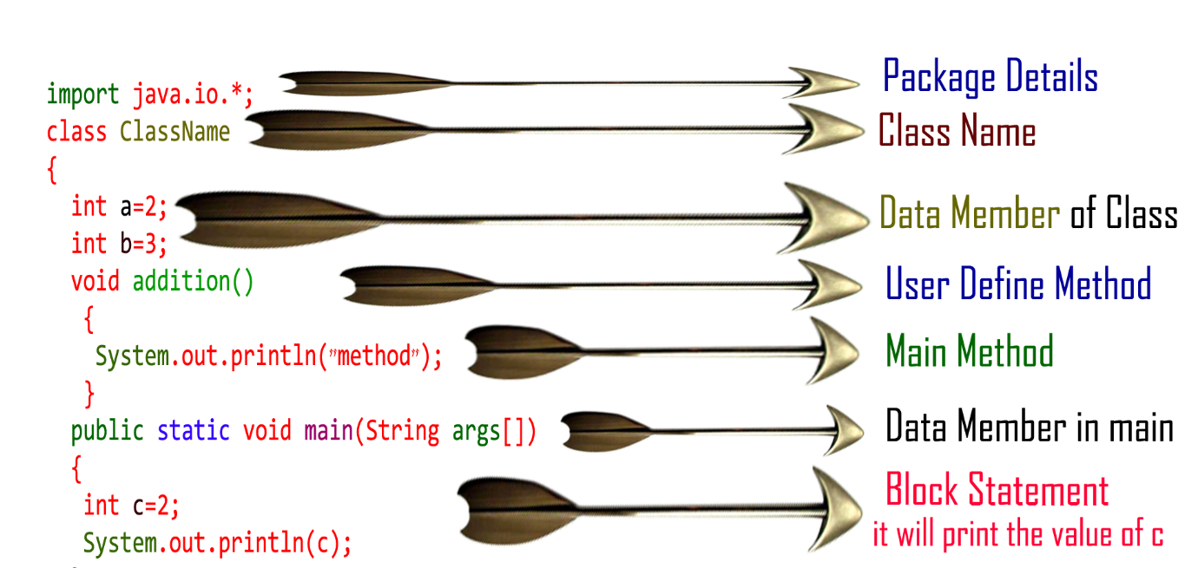
}
}

Class
Class is keyword used for developing user defined data type and every java program must start with a concept of class.

ClassName
"ClassName" represent a java valid variable name treated as a name of the class each and every class name in java is treated as user-defined data type.

Data member
Data member represents either instance or static they will be selected based on the name of the class.

User-defined methods
User-defined methods represents either instance or static they are meant for performing the operations either once or each and every time.

main() method
Each and every java program starts execution from the main() method. And hence main() method is known as program driver.

void
Since main() method of java is not returning any value and hence its return type must be void.

Static
Since main() method of java executes only once throughout the java program execution and hence its nature must be static.

public
Since main() method must be accessed by every java programmer and hence whose access specifier must be public.

String args[]
Each and every main() method of java must take array of objects of String.

Block of statements
Block of statements represents set of executable statements which are in term calling user-defined methods are containing business-logic.

Class
Class is keyword used for developing user defined data type and every java program must start with a concept of class.

18 What are constructors? explain different types of constructors with example.
Constructors:
A constructor is a public method (a method that can be accessed anywhere in a program) with the same name as the class and it enables an object to initialize
itself when it's created.
Ones defined, the constructor is automatically called immediately after the object is created, before the new operator completes.
Constructor have no return type, not even void.
There are two types of constructor:-
1. Default constructor:- Default constructor fires automatically and initializes all instance variable to the default values. It will fire in the absence of even if a single parameterized constructor.
2. Parameterized constructor:- If the method defines parameters inside the method in parenthesis, it is called parameterized constructor
A constructor initializes an object immediately upon creation. Once defined, the constructor is automatically called immediately after the object is created, before the new operator completes.
 Constructors have no return type, not even void. This is because the implicit return type of a class. constructor is the class type itself.
Example:-
class Box
{
double width; double height; double depth;
// This is the constructor for Box. Box(double w, double h, double d)
{
width = w; height = h; depth = d;
}
// compute and return volume double volume()
{
return width * height * depth;
}
}
class BoxDemo7
{
public static void main(String args[])
{
// declare, allocate, and initialize Box objects Box mybox1 = new Box(10, 20, 15);
Box mybox2 = new Box(3, 6, 9); double vol;
// get volume of first box vol = mybox1.volume();
System.out.println("Volume is " + vol);
// get volume of second box vol = mybox2.volume();
System.out.println("Volume is " + vol);
}
}
The output from this program is shown here:
Volume is 3000.0
Volume is 162.0

19 What is Inheritance? Explain different types of inheritance supported by Java with an example?

Inheritance in java is a mechanism in which one object acquires all the properties and behaviors of parent object.

Using inheritance, we can create a general class that defines traits common to a set of related items. This class can then be inherited by other, more specific classes, each adding those things that are unique to it.

The logic behind inheritance in java is that we can create new classes that from existing classes. When you inherit from an existing class, you can reuse methods and fields of parent class, and you can add new methods and fields also.

Inheritance represents the IS-A relationship, also known as parent-child relationship.

No Term Definition
1 Inheritance Inheritance is a process where one object acquires the properties of another object
2 Subclass Class which inherits the properties of another object is called as subclass
3 Superclass Class whose properties are inherited by subclass is called as superclass
4 Keywords Used extends and implements
Purpose of Inheritance
code reusability: the same methods and variables which are defined in a parent/super/base class can be used in the child/sub/derived class.
It promotes polymorphism by allowing method overriding.
Disadvantages of Inheritance
The main disadvantage of using inheritance is that the two classes (parent and child class) get tightly coupled.
This means that if we change the code of parent class, it will affect to all the child classes which are inheriting/deriving the parent class, and hence, it cannot be independent of each other.
Syntax of Java Inheritance
class Subclass-name extends Superclass-name
{
//methods and fields
}
extends is the keyword used to inherit the properties of a class. Following is the syntax of extends keyword. It indicates that you are making a new class that derives from an existing class. The meaning of "extends" is to increase the functionality.

In the terminology of Java, a class which is inherited is called parent or super class and the new class is called child or subclass.

Let us see how extends keyword is used to achieve Inheritance.
class Vehicle.
{
......
}
class Car extends Vehicle
{
....... //extends the property of vehicle class.
}
Now based on above example. In OOPs term we can say that,

Vehicle is super class of Car.
Car is sub class of Vehicle.
Car IS-A Vehicle.
Simple example of Inheritance
Program:
class Parent
{
public void pMethod()
{
System.out.println("Parent method");
}
}
public class Child extends Parent {
public void cMethod()
{
System.out.println("Child method");
}
public static void main(String[] args)
{
Child cobj = new Child();
cobj.cMethod(); //method of Child class
cobj.pMethod(); //method of Parent class
}
}
Output:
Child method
Parent method

Types of inheritance in java
On the basis of class, there can be three types of inheritance in java:

Single Inheritance
Multilevel Inheritance
Hierarchical Inheritance
NOTE :Multiple inheritance is not supported in java

inheritance in javaSingle Inheritance
and Multilevel Inheritance in java
Single Inheritance Example
Save File As: MainClass.java Program:
class Animal{
void eat(){
System.out.println("eating grass...");
}
}

class Cow extends Animal{
void age(){
System.out.println("age 21");
}
}

class MainClass{
public static void main(String args[]){
Cow d=new Cow();
d.age();
d.eat();
}
}
Program:
age 21
eating grass...
Press any key to continue . . .
Multilevel Inheritance Example
Save File As: MainClass.java Program:
class Animal{
void eat(){
System.out.println("eating...Animal class...eat method");
}
}

class Dog extends Animal{
void bark(){
System.out.println("barking...Dog class...bark method");
}
}

class BabyDog extends Dog{
void weep(){
System.out.println("weeping...BabyDog class...weep method");
}
}

class MainClass{
public static void main(String args[]){
BabyDog obj=new BabyDog();
obj.weep();
obj.bark();
obj.eat();
}
}
Program:
weeping...BabyDog class...weep method
barking...Dog class...bark method
eating...Animal class...eat method
Press any key to continue . . .
Hierarchical Inheritancee in java
Hierarchical Inheritance Example
Save File As: MainClass.java Program:
class Animal{
void animalMethod(){
System.out.println("iam inside Animal class...");
}
}

class Dog extends Animal{
void sms(){
System.out.println("Hi You are Dog...");
}
}

class Cat extends Animal{
void message(){
System.out.println("Hi You are cat...");
}
}

class MainClass{
public static void main(String args[]){
Cat c=new Cat();
c.message();
c.animalMethod();
//c.sms(); error
}
}
Program:
Hi You are cat...
iam inside Animal class...

In java programming, multiple and hybrid inheritance is supported through interface only. We will learn about interfaces later.

20 i)Write short notes on i)this keyword ii) static keyword
this keyword
Sometimes a method will need to refer to the object that invoked it. To allow this, Java
defines the this keyword. this can be used inside any method to refer to the current object.That is, this is always a reference to the object on which the method was invoked.
You can use this anywhere a reference to an object of the current class type is permitted. Method declaration with the keyword static(class method) cannot use this.
To better understand what this refers to, consider the following version of Box( ):
// A redundant use of this. Box(double w, double h, double d)
{
this.width = w; this.height = h; this.depth = d;
}
This version of Box( ) operates exactly like the earlier version. The use of this is redundant, but perfectly correct. Inside Box( ), this will always refer to the invoking object. While
it is redundant in this case, this is useful in other contexts, one of which is explained in the next section.
Instance Variable Hiding:
As you know, it is illegal in Java to declare two local variables with the same name inside the same or enclosing scopes. Interestingly, you can have local variables, including formal parameters to methods, which overlap with the names of the class’ instance variables. However, when a local variable has the same name as an instance variable, the local variable hides the instance variable.
This is why width, height, and depth were not used as the names of the parameters to the Box( ) constructor inside the Box class. If they had been, then width would have referred to the formal parameter, hiding the instance variable width. While it is usually easier to simply use different names, there is another way around this situation. Because this lets you refer directly to the object, you can use it to resolve any name space collisions that might occur
between instance variables and local variables. For example, here is another version of Box( ), which uses width, height, and depth for parameter names and then uses this to access the instance variables by the same name:
// Use this to resolve name-space collisions. Box(double width, double height, double depth)
{
this.width = width; this.height = height;
this.depth = depth;
}
A word of caution: The use of this in such a context can sometimes be confusing, and some programmers are careful not to use local variables and formal parameter
names that hide instance variables. Of course, other programmers believe the contrary— that it is a good convention to use the same names for clarity, and use this to overcome the instance variable hiding. It is a matter of taste which approach you adopt.
Although this is of no significant value in the examples just shown, it is very useful
in certain situations.
Static
When a member is declared static, it can be accessed before any objects of its class declared, and without reference to any object.
E such a member, precede its declaration with the keyword static. You can declare both methods and variables to be static.
The common example of a static member is main(). main() is declared as static because it must be called before any objects exist.
Rules for static members :
They can only call other static methods. They must only access static data.
They cannot refer to this or super in any way. (The keyword super is: relates to inheritance and is described in Chapter 4)
If you need to do computation in order to initialize your static variables, you can declare static block
which gets executed exactly once, when the class is first loaded The following program shows a class that has a static method, some static variables, and a static initialization block.
/* Program to demonstrate static variables, methods, and blocks */ class StaticDemo1
{
static int a = 5; static int b;
static void display(int c)
{
System.out.println(" a = "+a); System.out.println(" b = "+b); System.out.println(" c = "+c);
}
static
{
System.out.println(" static block initialized ");
b = a * 5;
}
public static void main(String args[])
{
display(40);
}
}
/* output
F:\java\static>javac StaticDemo1.java
F:\java\static>java StaticDemo1 static block initialized....
a = 5
b = 25
c = 40 */

21 Explain interface in java with an example.

Java Interface
An interface is a fully abstract class. It includes a group of abstract methods (methods without a body).
We use the interface keyword to create an interface in Java. For example,
interface Language {
public void getType();

public void getVersion();
}
Here,
- Language is an interface.
- It includes abstract methods: getType() and getVersion().

Implementing an Interface
Like abstract classes, we cannot create objects of interfaces.
To use an interface, other classes must implement it. We use the implements keyword to implement an interface.

Example 1: Java Interface
interface Polygon {
void getArea(int length, int breadth);
}

// implement the Polygon interface
class Rectangle implements Polygon {

// implementation of abstract method
public void getArea(int length, int breadth) {
System.out.println("The area of the rectangle is " + (length * breadth));
}
}

class Main {
public static void main(String[] args) {
Rectangle r1 = new Rectangle();
r1.getArea(5, 6);
}
}
Output
The area of the rectangle is 30
In the above example, we have created an interface named Polygon. The interface contains an abstract method getArea().
Here, the Rectangle class implements Polygon. And, provides the implementation of the getArea() method.

Example 2: Java Interface
// create an interface
interface Language {
void getName(String name);
}

// class implements interface
class ProgrammingLanguage implements Language {

// implementation of abstract method
public void getName(String name) {
System.out.println("Programming Language: " + name);
}
}

class Main {
public static void main(String[] args) {
ProgrammingLanguage language = new ProgrammingLanguage();
language.getName("Java");
}
}
Output
Programming Language: Java
In the above example, we have created an interface named Language. The interface includes an abstract method getName().
Here, the ProgrammingLanguage class implements the interface and provides the implementation for the method.

Implementing Multiple Interfaces
In Java, a class can also implement multiple interfaces. For example,
interface A {
// members of A
}

interface B {
// members of B
}

class C implements A, B {
// abstract members of A
// abstract members of B
}

Extending an Interface
Similar to classes, interfaces can extend other interfaces. The extends keyword is used for extending interfaces. For example,
interface Line {
// members of Line interface
}

// extending interface
interface Polygon extends Line {
// members of Polygon interface
// members of Line interface
}
Here, the Polygon interface extends the Line interface. Now, if any class implements Polygon, it should provide implementations for all the abstract methods of both Line and Polygon.

Extending Multiple Interfaces
An interface can extend multiple interfaces. For example,
interface A {
...
}
interface B {
...
}

interface C extends A, B {
...
}

Advantages of Interface in Java
Now that we know what interfaces are.
- Similar to abstract classes, interfaces help us to achieve abstraction in Java.
Here, we know getArea() calculates the area of polygons but the way area is calculated is different for different polygons. Hence, the implementation of getArea() is independent of one another.
- Interfaces provide specifications that a class (which implements it) must follow.
In our previous example, we have used getArea() as a specification inside the interface Polygon. This is like setting a rule that we should be able to get the area of every polygon.
Now any class that implements the Polygon interface must provide an implementation for the getArea() method.
- Interfaces are also used to achieve multiple inheritance in Java. For example,
- interface Line {
- …
- }

- interface Polygon {
- …
- }

- class Rectangle implements Line, Polygon {
- …
}
Here, the class Rectangle is implementing two different interfaces. This is how we achieve multiple inheritance in Java.
All the methods inside an interface are implicitly public and all fields are implicitly public static final. For example,
interface Language {

// by default public static final
String type = "programming language";

// by default public
void getName();
}

default methods in Java Interfaces
With the release of Java 8, we can now add methods with implementation inside an interface. These methods are called default methods.
To declare default methods inside interfaces, we use the default keyword. For example,
public default void getSides() {
// body of getSides()
}

Why default methods?
Let's take a scenario to understand why default methods are introduced in Java.
Suppose, we need to add a new method in an interface.
We can add the method in our interface easily without implementation. However, that's not the end of the story. All our classes that implement that interface must provide an implementation for the method.
If a large number of classes were implementing this interface, we need to track all these classes and make changes to them. This is not only tedious but error-prone as well.
To resolve this, Java introduced default methods. Default methods are inherited like ordinary methods.
Let's take an example to have a better understanding of default methods.

Example: Default Method in Java Interface
interface Polygon {
void getArea();

// default method
default void getSides() {
System.out.println("I can get sides of a polygon.");
}
}

// implements the interface
class Rectangle implements Polygon {
public void getArea() {
int length = 6;
int breadth = 5;
int area = length * breadth;
System.out.println("The area of the rectangle is " + area);
}

// overrides the getSides()
public void getSides() {
System.out.println("I have 4 sides.");
}
}

// implements the interface
class Square implements Polygon {
public void getArea() {
int length = 5;
int area = length * length;
System.out.println("The area of the square is " + area);
}
}

class Main {
public static void main(String[] args) {

// create an object of Rectangle
Rectangle r1 = new Rectangle();
r1.getArea();
r1.getSides();

// create an object of Square
Square s1 = new Square();
s1.getArea();
s1.getSides();
}
}
Output
The area of the rectangle is 30
I have 4 sides.
The area of the square is 25
I can get sides of a polygon.
In the above example, we have created an interface named Polygon. It has a default method getSides() and an abstract method getArea().
Here, we have created two classes Rectangle and Square that implement Polygon.
The Rectangle class provides the implementation of the getArea() method and overrides the getSides() method. However, the Square class only provides the implementation of the getArea() method.
Now, while calling the getSides() method using the Rectangle object, the overridden method is called. However, in the case of the Square object, the default method is called.

private and static Methods in Interface
The Java 8 also added another feature to include static methods inside an interface.
Similar to a class, we can access static methods of an interface using its references. For example,
// create an interface
interface Polygon {
staticMethod(){..}
}

// access static method
Polygon.staticMethod();
Note: With the release of Java 9, private methods are also supported in interfaces.
We cannot create objects of an interface. Hence, private methods are used as helper methods that provide support to other methods in interfaces.

Practical Example of Interface
Let's see a more practical example of Java Interface.
// To use the sqrt function
import java.lang.Math;

interface Polygon {
void getArea();

// calculate the perimeter of a Polygon
default void getPerimeter(int... sides) {
int perimeter = 0;
for (int side: sides) {
perimeter += side;
}

System.out.println("Perimeter: " + perimeter);
}
}

class Triangle implements Polygon {
private int a, b, c;
private double s, area;

// initializing sides of a triangle
Triangle(int a, int b, int c) {
this.a = a;
this.b = b;
this.c = c;
s = 0;
}

// calculate the area of a triangle
public void getArea() {
s = (double) (a + b + c)/2;
area = Math.sqrt(s*(s-a)*(s-b)*(s-c));
System.out.println("Area: " + area);
}
}

class Main {
public static void main(String[] args) {
Triangle t1 = new Triangle(2, 3, 4);

// calls the method of the Triangle class
t1.getArea();

// calls the method of Polygon
t1.getPerimeter(2, 3, 4);
}
}
Output
Area: 2.9047375096555625
Perimeter: 9
In the above program, we have created an interface named Polygon. It includes a default method getPerimeter() and an abstract method getArea().
We can calculate the perimeter of all polygons in the same manner so we implemented the body of getPerimeter() in Polygon.
Now, all polygons that implement Polygon can use getPerimeter() to calculate perimeter.
However, the rule for calculating the area is different for different polygons. Hence, getArea() is included without implementation.
Any class that implements Polygon must provide an implementation of getArea().

22 How to Handle the Exception in Java?

23 Explain: Life cycle of the thread.
When a thread is created, a new thread of control is added to the current process. Every process has at least one thread of control, in the program's main() routine. Each thread in the process runs simultaneously and has access to the calling process's global data. In addition, each thread has its own private attributes and call stack.
A thread can be in one of the five states. According to sun, there is only 4 states in thread life cycle in java new, runnable, non-runnable and terminated. There is no running state.
But for better understanding the threads, we are explaining it in the 5 states.
Thread having below states.
- New State
- Ready State
- Running State
- Dead State
- Non-Runnable States (Blocked)
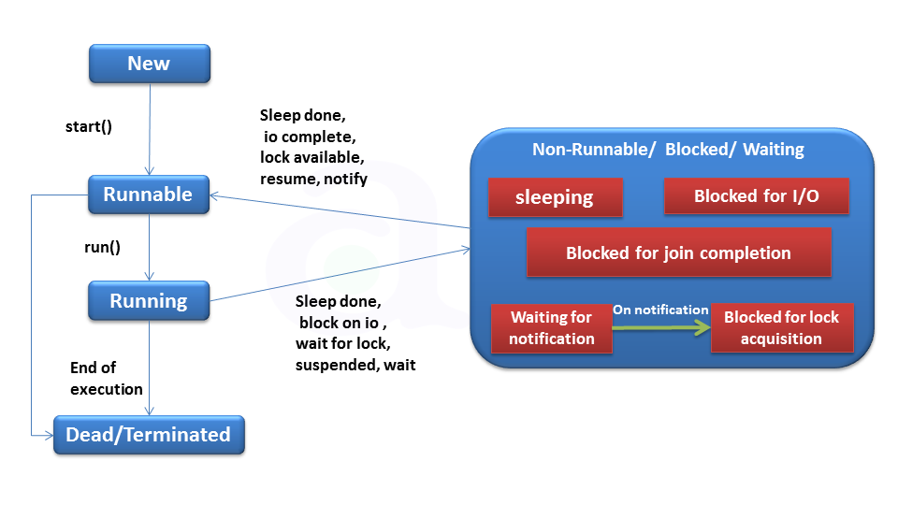

1.New State:
A thread has been created but not started yet. A thread will be started by calling its start() method.

2.Runnable State:
This state is also called ready to run stage also called queue. A thread starts in the runnable state by calling start() method.
The Thread scheduler decides which thread runs and how long.

3.Running State:
If a Thread is executing that means Thread is in Running stage.

4.Dead State:
Once a Thread reached dead state it can not run again.

5. Non-runnable States:
This is the state when the thread is still alive, but is currently not eligible to run.
- A Running Thread transit to one of the non-runnable states, depending upon the circumstances.
- A Thread remains non-runnable until a special transition occurs.
- A Thread does not go directly to the running state from non-runnable state.
- But transits first to runnable state.
- Sleeping: The Thread sleeps for the specified amount of time.
- Blocked for I/O: The Thread waits for a blocking operation to complete.
- Blocked for join completion: The Thread waits for completion of another Thread.
- Waiting for notification: The Thread waits for notification another Thread.
- Blocked for lock acquisition: The Thread waits to acquire the lock of an object.
- JVM executes the Thread based on their priority and scheduling.

24 Explain about hierarchy of exceptions in java

Hierarchy of Java Exception classes
Exceptions are objects, and objects are defined using classes. The root class for exceptions is java.lang.Throwable
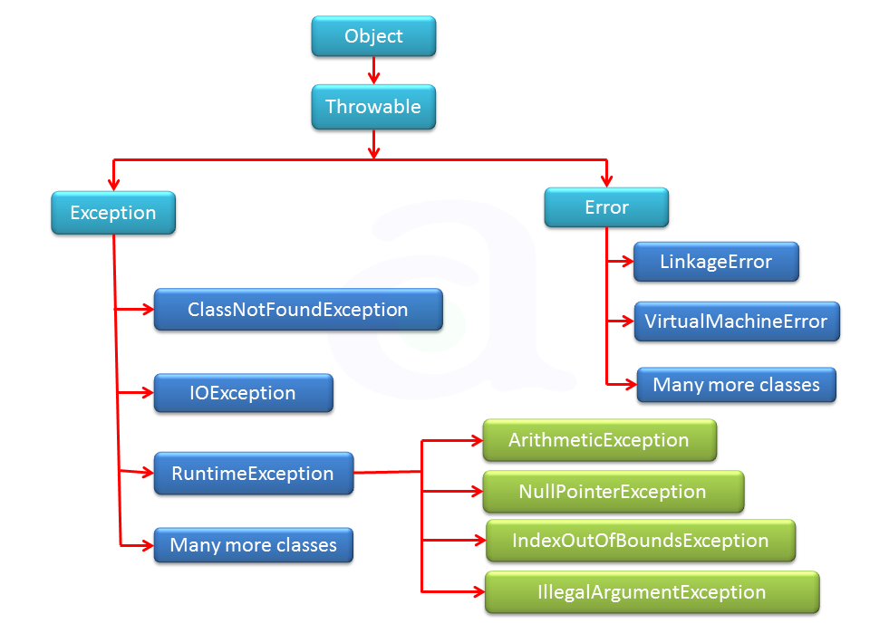
System errors are thrown by the JVM and are represented in the Error class. The Error class describes internal system errors, though such errors rarely occur. If one does, there is little you can do beyond notifying the user and trying to terminate the program gracefully. Examples of subclasses of Error are listed in table below.
Class | Reasons for Exception
LinkageError | A class has some dependency on another class, but the latter class has  changed incompatibly after the compilation of the former class.
VirtualMachineError | The JVM is broken or has run out of the resources it needs in order to  continue operating.
Exceptions are represented in the Exception class, which describes errors caused by your program and by external circumstances. These errors can be caught and handled by your program. Examples of subclasses of Exception are listed in table below.
Class | Reasons for Exception
ClassNotFoundException | Attempt to use a class that does not exist. This exception would occur, for example, if you tried to  run a nonexistent class using the java command, or if your program were composed of, say,  three class files, only two of which could be found.
IOException | Related to input/output operations, such as invalid input, reading past the end of a file, and opening  a nonexistent file. Examples of subclasses of IOException are InterruptedIOException ,  EOFException (EOF is short for End of File), and FileNotFoundException
Runtime exceptions are represented in the RuntimeException class, which describes programming errors, such as bad casting, accessing an out-of-bounds array, and numeric errors. Runtime exceptions are generally thrown by the JVM. Examples of subclasses are listed in table below.
Class | Reasons for Exception
ArithmeticException | Dividing an integer by zero. Note that floating-point arithmetic  does not throw exceptions (see Appendix E, Special Floating-  Point Values).
NullPointerException | Attempt to access an object through a null reference variable.
IndexOutOfBoundsException | Index to an array is out of range.
IllegalArgumentException | A method is passed an argument that is illegal or inappropriate.

Exception are categorized into 3 category.
  - Checked Exception
The exception that can be predicted by the programmer at the compile time.Example : File that need to be opened is not found. These type of exceptions must be checked at compile time.
  - Unchecked Exception
Unchecked exceptions are the class that extends RuntimeException. Unchecked exception are ignored at compile time. Example : ArithmeticException, NullPointerException, Array Index out of Bound exception. Unchecked exceptions are checked at runtime.
  - Error
Errors are typically ignored in code because you can rarely do anything about an error. Example :if stack overflow occurs, an error will arise. This type of error cannot be handled in the code.

Common scenarios where exceptions may occur
There are given some scenarios where unchecked exceptions can occur. They are as follows:

1) Scenario where ArithmeticException occurs
If we divide any number by zero, there occurs an ArithmeticException.
int vara=50/0;//ArithmeticException

2) Scenario where NullPointerException occurs
If we have null value in any variable, performing any operation by the variable occurs an NullPointerException.
String strng=null;
System.out.println(strng.length());//NullPointerException

3) Scenario where NumberFormatException occurs
The wrong formatting of any value, may occur NumberFormatException. Suppose I have a string variable that have characters, converting this variable into digit will occur NumberFormatException.
<
String strng="abc";
int i=Integer.parseInt(strng);//NumberFormatException

4) Scenario where ArrayIndexOutOfBoundsException occurs
If you are inserting any value in the wrong index, it would result ArrayIndexOutOfBoundsException as shown below:
int array[]=new int[5];
array[10]=50; //ArrayIndexOutOfBoundsException

25 Explain about creation and implementation of thread with an example program

26 With an example explain the concept of recursion
In Java, a method that calls itself is known as a recursive method. And, this process is known as recursion.
A physical world example would be to place two parallel mirrors facing each other. Any object in between them would be reflected recursively.

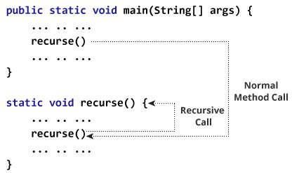
Working of Java Recursion
In the above example, we have called the recurse() method from inside the main method. (normal method call). And, inside the recurse() method, we are again calling the same recurse method. This is a recursive call.
In order to stop the recursive call, we need to provide some conditions inside the method. Otherwise, the method will be called infinitely.
Hence, we use the if...else statement (or similar approach) to terminate the recursive call inside the method.

Example: Factorial of a Number Using Recursion
class Factorial {

static int factorial( int n ) {
if (n != 0) // termination condition
return n * factorial(n-1); // recursive call
else
return 1;
}

public static void main(String[] args) {
int number = 4, result;
result = factorial(number);
System.out.println(number + " factorial = " + result);
}
}
Output:
4 factorial = 24
In the above example, we have a method named factorial(). The factorial() is called from the main() method. with the number variable passed as an argument.
Here, notice the statement,
return n * factorial(n-1);
The factorial() method is calling itself. Initially, the value of n is 4 inside factorial(). During the next recursive call, 3 is passed to the factorial() method. This process continues until n is equal to 0.
When n is equal to 0, the if statement returns false hence 1 is returned. Finally, the accumulated result is passed to the main() method.

27 Write a simple Java program to implement basic Calculator operations.
import java.util.Scanner;

public class JavaExample {

public static void main(String[] args) {

double num1, num2;
Scanner scanner = new Scanner(System.in);
System.out.print("Enter first number:");

/* We are using data type double so that user
* can enter integer as well as floating point
* value
*/
num1 = scanner.nextDouble();
System.out.print("Enter second number:");
num2 = scanner.nextDouble();

System.out.print("Enter an operator (+, -, *, /): ");
char operator = scanner.next().charAt(0);

scanner.close();
double output;

switch(operator)
{
case '+':
output = num1 + num2;
break;

case '-':
output = num1 - num2;
break;

case '*':
output = num1 * num2;
break;

case '/':
output = num1 / num2;
break;

/* If user enters any other operator or char apart from
* +, -, * and /, then display an error message to user
*
*/
default:
System.out.printf("You have entered wrong operator");
return;
}

System.out.println(num1+" "+operator+" "+num2+": "+output);
}
}

28 Describe the following i) Features of Java ii) Data types in Java
Features
(1) Java Is Small and Simple
• Java is modeled after C and C++. The object-oriented approach, and most of Java's syntax, is adapted from C++.
• Programmers who are familiar with that language (or with C) will have a much easier time learning Java because of the common features.
(2) Java Is Object Oriented
• Object-oriented programming OOP organizes a program as a set of components called objects.
• These objects exist independently of each other, and they have rules for communicating with other objects and for telling those objects to do things.
• Java inherits its object-oriented concepts from C++ The language includes a set of class libraries that provide basic variable types, system input and output capabilities, and other functions.
It also includes classes to support networking, Internet protocols, and graphical user interface functions.
(3) Java Is Secure
• Java is a much more secure language. Java provides security on several different levels. First, the language was designed to make it extremely difficult to execute damaging code. Another level of security is the bytecode verifier.
• Java programs are compiled into sets of instructions called bytecodes. Before a Java program is run, a verifier checks each bytecode to make sure that nothing suspicious is going on. In addition to these measures, Java has several safeguards that apply to applets
(4) Java Is Platform Independent
1. Platform independence is the ability of the same program to work on different operating systems
2. Java is completely platform independent. Java's variable types have the same size across all Java development platforms. Also, a Java .class file of bytecode instructions can execute on any platform without alteration.
(5) Java Is Compiled & Interpretd
1. Before you can run a program written in the Java language, the program must be compiled by the Java compiler. The compilation results in a "byte-code" file that, while similar to a machine- code file, can be executed under any operating system that has a Java interpreter.
2. This interpreter reads in the byte-code file and translates the byte-code commands into machine-language commands that can be directly executed by the machine that's running the Java program. You could say, then, that Java is both a compiled and interpreted language.
(6) Java Is Multi-threaded
1. Java programs can contain multiple threads of execution, which enables programs to handle several tasks concurrently. For example, a multi-threaded program can render an image on the screen in one thread while continuing to accept keyboard input from the user in the main
thread.
2. All applications have at least one thread, which represents the program's main path of execution.
(7) Java Is Garbage Collected
1. Java programs do their own garbage collection, which means that programs are not required to delete objects that they allocate in memory.
2. This relieves programmers of virtually all memory-management problems.
(8) Java Is Robust
1. Because the Java interpreter checks all system access performed within a program, Java programs cannot crash the system.
2. Instead, when a serious error is discovered, Java programs create an exception. This exception can be captured and managed by the program without any risk of bringing down the system.
(9) High Performance
1. Java is "high performance" because its bytecode is efficient and has multithreading built in for applications that need to perform multiple concurrent activities.
(10) Dynamic
1. Java is dynamic, so your applications are adaptable to changing environments because Java's architecture allows you to dynamically load classes at runtime from anywhere on the network, which means that you can add functionality to
existing applications by simply linking in new classes
Data Types:-
Java defines eight simple (or elemental) types of data: byte, short, int, long, char, float, double, and boolean. These can be put in four groups:
Data type Description
Integers This group includes byte, short, int, and long, which are for whole valued signed numbers.
Floating- point numbers This group includes float and double, which represent numbers with fractional precision.
Characters This group includes char, which represents symbols in a
character set, like letters and numbers.
Boolean This group includes boolean, which is a special type for representing true/false values.
Data types in java under various categories. Basic 2 type primitive & non primitive
Data types in java
1)Integer Data Types
Java define four integer types: byte, short, int, and long. Java does not support the concept of unsigned types and therefore all java values are signed meaning they can be positive or negative . Each of these types takes up a different amount of space in memoryThe width and
ranges of these integer types vary widely, as shown in this table:
Length Data Type Range
8 bits byte -128 to +127
16 bits short -32768 to+32767
32 bits int -2147483648 to +2147483647
64 bits long -9223372036854775808 to +9223372036854775807

byte:-
The smallest integer type is byte. This is a signed 8-bit type that has a range from –128 to 127. Variables of type byte are especially useful when you’re working with a stream of data from a network or file. They are also useful when you’re working with raw binary data that may not be directly compatible with Java’s other built-in types.
Byte variables are declared by use of the byte keyword. For example, the following declares two byte variables called b and c:
byte b, c;
short :-
short is a signed 16-bit type. It has a range from –32,768 to 32,767. It is probably the least-used Java type, since it is defined as having its high byte first (called big-endian format). This type is mostly applicable to 16-bit computers, which are becoming increasingly scarce.
Here are some examples of short variable declarations:
short s; short t;
“Endianness” describes how multibyte data types, such as short, int, and long, are stored in memory. If it takes 2 bytes to represent a short, then which one comes first, the most significant or the least significant? To say that a machine is big-endian, means that the most significant byte is first, followed by the least significant one. Machines such as the SPARC and PowerPC are big-endian, while the Intel x86 series is little-endian.
int:-
The most commonly used integer type is int. It is a signed 32-bit type that has a range from –2,147,483,648 to 2,147,483,647. In addition to other uses, variables of type int are commonly employed to control loops and to index arrays. Any time you have an integer expression involving bytes, shorts, ints, and literal numbers, the entire expression is promoted to int before the calculation is done.
The int type is the most versatile and efficient type, and it should be used most of the time when you want to create a number for counting or indexing arrays or doing integer math. It may seem that using short or byte will save space, but there is no guarantee that Java won’t promote those types to int internally anyway. Remember, type determines behavior, not size. (The only exception is arrays, where byte is guaranteed to use only one byte per array element, short will use two bytes, and int will use four.)
long:-
long is a signed 64-bit type and is useful for those occasions where an int type is not
large enough to hold the desired value. The range of a long is quite large. This makes it useful when big, whole numbers are needed.
We make integers long by appending the letter L & l at the end of the number.
2)Floating-Point Data Types:-
Floating-point numbers, also known as real numbers, are used when evaluating expressions that require fractional precision. For example, calculations such as square root, or transcendental such as sine and cosine, result in a value whose precision requires a floating-point type.
Java implements the standard (IEEE–754) set of floating-point types and operators. There are two kinds of floating-point types, float and double, which represent single- and double-
precision numbers, respectively. Their width and ranges are shown here:
Length Data Type Range
32 bits float 3.4e-038 to 3.4e+038
64 bits double 1.7e-308 to -1.7e+308
float :-
The type float specifies a single-precision value that uses 32 bits of storage. Single precision is faster on some processors and takes half as much space as double precision, but will become imprecise when the values are either very large or very small. Variables of type float are useful when you need a fractional component, but don’t require a large degree of precision. For example, float can be useful when representing dollars and cents.
Here are some example float variable declarations:
float hightemp, lowtemp;
double :-
Double precision, as denoted by the double keyword, uses 64 bits to store a value. Double precision is actually faster than single precision on some modern processors that have been optimized for high-speed mathematical calculations. All transcendental math
functions, such as sin( ), cos( ), and sqrt( ), return double values. When you need to maintain accuracy over many iterative calculations, or are manipulating large-valued numbers, double is the best choice.
3) Character Data Type
The character data type (char) is used to store single Unicode characters. Because the Unicode character set is composed of 16-bit values, the char data type is stored as a 16- bit unsigned integer
4) booleans:-
Java has a simple type, called boolean, for logical values. It can have only one of two possible values, true or false. This is the type returned by all relational operators, such as a
< b. boolean is also the type required by the conditional expressions that govern the control
statements such as if and for.

29 Explain with an example: Recursion.

30 Write short note: Access Protection in java.
Java’s four level of access protection: Public
Private Protected Default
Some aspects of access control are related mostly to inheritance or package.(A package is,
essentially, a grouping of classes)protected is applied only when inheritance is invoked. : Public Access:
When a member of a class is modified by public specifier ,then that member can be accessed by any other code. Now you can understand why main() has always been preceded by the public specifier.it is called by code that is outside the program that is by java run time system
Private Access: when a member of class is specified as private, then that member can only be accessed by other members of its class.
Default Access: when no specifier is used then by default the member of class is public within its own package, but cannot be accessed outside of its package.in the classes development so far ,all members of a class have use the default access mode .which is essentially public. This access specifier is also known as friendly access. Difference between default access and public modifier is given below :
Public default
The public modifier makes fields visible in all classes ,regardless of their packages The default/friendly access makes fields visible only in the same package but not other packages.
Access specifier precedes the rest of a members type specification. That is it must begin a members declaration statement.
E.g
class member syntax
instance variable public int i;
private float f;
instance method private float method(int x,flat y)
{
}

Example of public & private
/* Program to demonstrate Access Protection */ class Demo
{

int p; // default access public int q; // public access private int r; // private access
// methods to access r void setr(int i)
{ // set r's value r = i;
}
int getr()
{ // get r's value return r;
}
}
class AccessProDemo
{
public static void main(String args[])
{
Demo d= new Demo();
// OK : 'p' and 'q' may be accessed directly d.p=300;
d.q=400;
// NOT OK : 'r' cannot be accessed outside the class, hence will cause an error
// d.r=50;
// You must access 'r' through its methods d.setr(500); //OK
System.out.println(" p, q, and r = "+d.p+", "+d.q+", and "+d.getr());
}
}
o/p:-
P, q, and r =300,400, and 500

31 With an example explain the concept of Polymorphism.

Java Polymorphism
Polymorphism is an important concept of object-oriented programming. It simply means more than one form.
That is, the same entity (method or operator or object) can perform different operations in different scenarios.

Example: Java Polymorphism
class Polygon {

// method to render a shape
public void render() {
System.out.println("Rendering Polygon...");
}
}

class Square extends Polygon {

// renders Square
public void render() {
System.out.println("Rendering Square...");
}
}

class Circle extends Polygon {

// renders circle
public void render() {
System.out.println("Rendering Circle...");
}
}

class Main {
public static void main(String[] args) {

// create an object of Square
Square s1 = new Square();
s1.render();

// create an object of Circle
Circle c1 = new Circle();
c1.render();
}
}
Output
Rendering Square...
Rendering Circle...
In the above example, we have created a superclass: Polygon and two subclasses: Square and Circle. Notice the use of the render() method.
The main purpose of the render() method is to render the shape. However, the process of rendering a square is different than the process of rendering a circle.
Hence, the render() method behaves differently in different classes. Or, we can say render() is polymorphic.

Why Polymorphism?

Polymorphism allows us to create consistent code. In the previous example, we can also create different methods: renderSquare() and renderCircle() to render Square and Circle, respectively.
This will work perfectly. However, for every shape, we need to create different methods. It will make our code inconsistent.
To solve this, polymorphism in Java allows us to create a single method render() that will behave differently for different shapes.
The print() method is also an example of polymorphism. It is used to print values of different types like char, int, string, etc.
We can achieve polymorphism in Java using the following ways:
- Method Overriding
- Method Overloading
- Operator Overloading

Java Method Overriding
During inheritance in Java, if the same method is present in both the superclass and the subclass. Then, the method in the subclass overrides the same method in the superclass. This is called method overriding.
In this case, the same method will perform one operation in the superclass and another operation in the subclass. For example,

Example 1: Polymorphism using method overriding
class Language {
public void displayInfo() {
System.out.println("Common English Language");
}
}

class Java extends Language {
@Override
public void displayInfo() {
System.out.println("Java Programming Language");
}
}

class Main {
public static void main(String[] args) {

// create an object of Java class
Java j1 = new Java();
j1.displayInfo();

// create an object of Language class
Language l1 = new Language();
l1.displayInfo();
}
}
Output:
Java Programming Language
Common English Language
In the above example, we have created a superclass named Language and a subclass named Java. Here, the method displayInfo() is present in both Language and Java.
The use of displayInfo() is to print the information. However, it is printing different information in Language and Java.
Based on the object used to call the method, the corresponding information is printed.
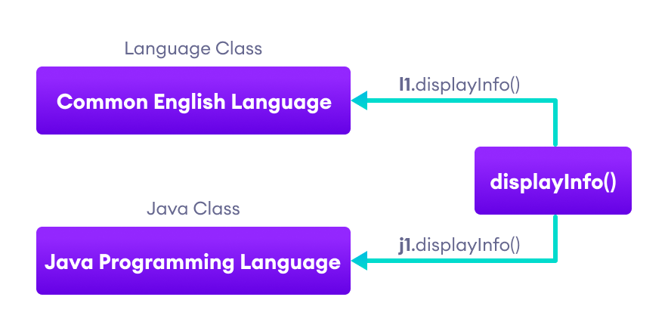
Working of Java Polymorphism
The method that is called is determined during the execution of the program. Hence, method overriding is a run-time polymorphism.

2. Java Method Overloading
In a Java class, we can create methods with the same name if they differ in parameters. For example,
void func() { ... }
void func(int a) { ... }
float func(double a) { ... }
float func(int a, float b) { ... }
This is known as method overloading in Java. Here, the same method will perform different operations based on the parameter.

Example 3: Polymorphism using method overloading
class Pattern {

// method without parameter
public void display() {
for (int i = 0; i < 10; i++) {
System.out.print("*");
}
}

// method with single parameter
public void display(char symbol) {
for (int i = 0; i < 10; i++) {
System.out.print(symbol);
}
}
}

class Main {
public static void main(String[] args) {
Pattern d1 = new Pattern();

// call method without any argument
d1.display();
System.out.println("\n");

// call method with a single argument
d1.display('#');
}
}
Output:
**********

##########
In the above example, we have created a class named Pattern. The class contains a method named display() that is overloaded.
// method with no arguments
display() {...}

// method with a single char type argument
display(char symbol) {...}
Here, the main function of display() is to print the pattern. However, based on the arguments passed, the method is performing different operations:
- prints a pattern of *, if no argument is passed or
- prints pattern of the parameter, if a single char type argument is passed.
The method that is called is determined by the compiler. Hence, it is also known as compile-time polymorphism.

3. Java Operator Overloading
Some operators in Java behave differently with different operands. For example,
- + operator is overloaded to perform numeric addition as well as string concatenation, and
- operators like &, |, and ! are overloaded for logical and bitwise operations.
Let's see how we can achieve polymorphism using operator overloading.
The + operator is used to add two entities. However, in Java, the + operator performs two operations.
1. When + is used with numbers (integers and floating-point numbers), it performs mathematical addition. For example,
int a = 5;
int b = 6;

// + with numbers
int sum = a + b; // Output = 11
2. When we use the + operator with strings, it will perform string concatenation (join two strings). For example,
String first = "Java ";
String second = "Programming";

// + with strings
name = first + second; // Output = Java Programming
Here, we can see that the + operator is overloaded in Java to perform two operations: addition and concatenation.

In languages like C++, we can define operators to work differently for different operands. However, Java doesn't support user-defined operator overloading.

Polymorphic Variables
A variable is called polymorphic if it refers to different values under different conditions.
Object variables (instance variables) represent the behavior of polymorphic variables in Java. It is because object variables of a class can refer to objects of its class as well as objects of its subclasses.

Example: Polymorphic Variables
class ProgrammingLanguage {
public void display() {
System.out.println("I am Programming Language.");
}
}

class Java extends ProgrammingLanguage {
@Override
public void display() {
System.out.println("I am Object-Oriented Programming Language.");
}
}

class Main {
public static void main(String[] args) {

// declare an object variable
ProgrammingLanguage pl;

// create object of ProgrammingLanguage
pl = new ProgrammingLanguage();
pl.display();

// create object of Java class
pl = new Java();
pl.display();
}
}
Output:
I am Programming Language.
I am Object-Oriented Programming Language.
In the above example, we have created an object variable pl of the ProgrammingLanguage class. Here, pl is a polymorphic variable. This is because,
- In statement pl = new ProgrammingLanguage(), pl refer to the object of the ProgrammingLanguage class.
- And, in statement pl = new Java(), pl refer to the object of the Java class.
This is an example of upcasting in Java.

32 What is operator overloading? Explain with an example.
33 What is abstract method? Explain with an example.

Java Abstract Class and Abstract Methods

Java Abstract Class
The abstract class in Java cannot be instantiated (we cannot create objects of abstract classes). We use the abstract keyword to declare an abstract class. For example,
// create an abstract class
abstract class Language {
// fields and methods
}
...

// try to create an object Language
// throws an error
Language obj = new Language();
An abstract class can have both the regular methods and abstract methods. For example,
abstract class Language {

// abstract method
abstract void method1();

// regular method
void method2() {
System.out.println("This is regular method");
}
}

Java Abstract Method
A method that doesn't have its body is known as an abstract method. We use the same abstract keyword to create abstract methods. For example,
abstract void display();
Here, display() is an abstract method. The body of display() is replaced by ;.
If a class contains an abstract method, then the class should be declared abstract. Otherwise, it will generate an error. For example,
// error
// class should be abstract
class Language {

// abstract method
abstract void method1();
}

Example: Java Abstract Class and Method
Though abstract classes cannot be instantiated, we can create subclasses from it. We can then access members of the abstract class using the object of the subclass. For example,
abstract class Language {

// method of abstract class
public void display() {
System.out.println("This is Java Programming");
}
}

class Main extends Language {

public static void main(String[] args) {

// create an object of Main
Main obj = new Main();

// access method of abstract class
// using object of Main class
obj.display();
}
}
Output
This is Java programming
In the above example, we have created an abstract class named Language. The class contains a regular method display().
We have created the Main class that inherits the abstract class. Notice the statement,
obj.display();
Here, obj is the object of the child class Main. We are calling the method of the abstract class using the object obj.

Implementing Abstract Methods
If the abstract class includes any abstract method, then all the child classes inherited from the abstract superclass must provide the implementation of the abstract method. For example,
abstract class Animal {
abstract void makeSound();

public void eat() {
System.out.println("I can eat.");
}
}

class Dog extends Animal {

// provide implementation of abstract method
public void makeSound() {
System.out.println("Bark bark");
}
}

class Main {
public static void main(String[] args) {

// create an object of Dog class
Dog d1 = new Dog();

d1.makeSound();
d1.eat();
}
}
Output
Bark bark
I can eat.
In the above example, we have created an abstract class Animal. The class contains an abstract method makeSound() and a non-abstract method eat().
We have inherited a subclass Dog from the superclass Animal. Here, the subclass Dog provides the implementation for the abstract method makeSound().
We then used the object d1 of the Dog class to call methods makeSound() and eat().

If the Dog class doesn't provide the implementation of the abstract method makeSound(), Dog should also be declared as abstract. This is because the subclass Dog inherits makeSound() from Animal.

Accesses Constructor of Abstract Classes
An abstract class can have constructors like the regular class. And, we can access the constructor of an abstract class from the subclass using the super keyword. For example,
abstract class Animal {
Animal() {
….
}
}

class Dog extends Animal {
Dog() {
super();
...
}
}
Here, we have used the super() inside the constructor of Dog to access the constructor of the Animal.
super should always be the first statement of the subclass constructor.

Java Abstraction
The major use of abstract classes and methods is to achieve abstraction in Java.
Abstraction is an important concept of object-oriented programming that allows us to hide unnecessary details and only show the needed information.
This allows us to manage complexity by omitting or hiding details with a simpler, higher-level idea.
A practical example of abstraction can be motorbike brakes. We know what brake does. When we apply the brake, the motorbike will stop. However, the working of the brake is kept hidden from us.
The major advantage of hiding the working of the brake is that now the manufacturer can implement brake differently for different motorbikes, however, what brake does will be the same.
Let's take an example that helps us to better understand Java abstraction.

Example 3: Java Abstraction
abstract class MotorBike {
abstract void brake();
}

class SportsBike extends MotorBike {

// implementation of abstract method
public void brake() {
System.out.println("SportsBike Brake");
}
}

class MountainBike extends MotorBike {

// implementation of abstract method
public void brake() {
System.out.println("MountainBike Brake");
}
}

class Main {
public static void main(String[] args) {
MountainBike m1 = new MountainBike();
m1.brake();
SportsBike s1 = new SportsBike();
s1.brake();
}
}
Output:
MountainBike Brake
SportsBike Brake
In the above example, we have created an abstract super class MotorBike. The superclass MotorBike has an abstract method brake().
The brake() method cannot be implemented inside MotorBike. It is because every bike has different implementation of brakes. So, all the subclasses of MotorBike would have different implementation of brake().
So, the implementation of brake() in MotorBike is kept hidden.
Here, MountainBike makes its own implementation of brake() and SportsBike makes its own implementation of brake().

We can also use interfaces to achieve abstraction in Java.

Key Points to Remember
- We use the abstract keyword to create abstract classes and methods.
- An abstract method doesn't have any implementation (method body).
- A class containing abstract methods should also be abstract.
- We cannot create objects of an abstract class.
- To implement features of an abstract class, we inherit subclasses from it and create objects of the subclass.
- A subclass must override all abstract methods of an abstract class. However, if the subclass is declared abstract, it's not mandatory to override abstract methods.
- We can access the static attributes and methods of an abstract class using the reference of the abstract class. For example,
Animal.staticMethod();

34 Write a java program to create a thread and implement it.
A thread is a process in execution within a program. Within a program each thread defines a separate path of execution. A process contains multiple threads that executes according to program code. Multiple threads are used to do a work in parallel.
Benefits of using threads:
    - It allows to perform more than one task at a time.
    - Resource sharing between threads is easy.
    - It maximizes CPU utilization
    - It reduces the complexity of large programs.
    - It increases the speed of execution.

  - Creating Threads
There are two methods to create threads. They are
- Creating threads by extending Thread class.
- Creating threads by implementing Runnable interface

Creating threads by extending Thread class
The steps given below are used to create a thread by extending thread class.
- Define a thread subclass by extending from the super class thread.
- Override the thread class method run() in the extended class with the statements to be executed by the thread.
- Write the main class and define thread objects.
- Using the created thread objects start the thread using start() method.

  - Thread states
The status of a thread is provided by the thread state property. Because threads can be in more than one state at any given time, the value stored in Thread State can be a combination of the values in the thread state enumeration.
Thread methods
The important thread class methods are
- run()
This method should be overridden in our thread extended the superclass thread. This method contains the statements for the particular thread.
public void run(){ statements
}

- start()

This method is used to start the run() method. If the method is already started it throws illegal Thread state exception. The general form is
void start()

- sleep()
This method is used to block the currently executing thread. The general form is
static void sleep(longint a)
where
a- integer value. This gives the time for sleeping in milli seconds
- interrupt()
This method is used to interrupt the currently running thread. The general form is
void interrupt()

- interrupted()
The general form is
static boolean interrupted()
This method returns true, if the current thread is interrupted else false.
- isAlive()
This method is used to check whether the thread is running or not. The general form is
Boolean isActive()
This method returns true, if the thread is running else false.
- stop()
This method is used to stop the running thread. The general form is
void stop()

- yield()
This method is used to bring the stopped thread to run mode. The general form is

void yield()
- wait()
This method is used to stop the currently running thread. The general form is
void wait()

Program
package threadPrg;

class HelloThread extends Thread
{
public void run()
{
try{
for ( ; ; )
{
System.out.println("hello"); sleep(1000);
}
}
catch(Exception e){}
}
}

public class ThreadTest
{
public static void main(String[] args) throws Exception
{
Thread hello = new HelloThread();
hello.start();
System.out.println("Sorry, I must be leaving");
}
}

35 “Try statements can be implicitly nested via calls to methods”. Explain with an example.
Nested try Statements
The try statement can be nested. That is, a try statement can be inside the block of another try. Each time a try statement is entered, the context of that exception is pushed on the stack. If an inner try statement does not have a catch handler for a particular exception, the stack is unwound and the next try statement’s catch handlers are inspected for a match. This continues until one of the catch statements succeeds, or until all of the nested try statements are exhausted. If no catch statement matches, then the Java run-time system will handle the exception.

Why use nested try block
Sometimes a situation may arise where a part of a block may cause one error and the entire block itself may cause another error. In such cases, exception handlers have to be nested.

Syntax
....
try
{
statement 1;
statement 2;
try
{
statement 1;
statement 2;
}
catch(Exception e)
{
}
}
catch(Exception e)
{
}
....
Example Program
class NestedExcep
{
public static void main(String[] args)
{
try
{
int arr[]={1,0,4,2};
try
{
int x=arr[3]/arr[1];
}
catch(ArithmeticException ae)
{
System.out.println("divide by zero");
}
arr[4]=3;
}
catch(ArrayIndexOutOfBoundsException e)
{
System.out.println("array index out of bound exception");
}
}
}
divide by zero
array index out of bound exception
Press any key to continue . . .
Example Progra

36 Explain with an example to demonstrate ‘finally’.
A finally block contains all the crucial statements that must be executed whether exception occurs or not. The statements present in this block will always execute regardless of whether exception occurs in try block or not such as closing a connection, stream etc.

Syntax of Finally block
try {
//Statements that may cause an exception
}
catch {
//Handling exception
}
finally {
//Statements to be executed
}

A Simple Example of finally block
Here you can see that the exception occurred in try block which has been handled in catch block, after that finally block got executed.
class Example
{
public static void main(String args[]) {
try{
int num=121/0;
System.out.println(num);
}
catch(ArithmeticException e){
System.out.println("Number should not be divided by zero");
}
/* Finally block will always execute
* even if there is no exception in try block
*/
finally{
System.out.println("This is finally block");
}
System.out.println("Out of try-catch-finally");
}
}
Output:
Number should not be divided by zero
This is finally block
Out of try-catch-finally

Few Important points regarding finally block
1. A finally block must be associated with a try block, you cannot use finally without a try block. You should place those statements in this block that must be executed always.
2. Finally block is optional, as we have seen in previous tutorials that a try-catch block is sufficient for exception handling, however if you place a finally block then it will always run after the execution of try block.
3. In normal case when there is no exception in try block then the finally block is executed after try block. However if an exception occurs then the catch block is executed before finally block.
4. An exception in the finally block, behaves exactly like any other exception.
5. The statements present in the finally block execute even if the try block contains control transfer statements like return, break or continue.
Lets see an example to see how finally works when return statement is present in try block:

37 Explain the arrays and its types in detail with example program.
An array is a collection of similar data types. or we can say array is a container object that hold values of homogenous type. the size of an array is fixed and cannot increase to accommodate more elements. The first element of an array starts with zero.
It is also known as static data structure because size of an array must be specified at the time of its declaration.
An array can be either primitive or reference type. It gets memory in heap area. Index of array starts from zero to size-1.
In simple words, it’s a programming construct which helps to replace this

x0=0;
x1=1;
x2=2;
x3=3;
x4=4;
x5=5;
with this …
x[0]=0;
x[1]=1;
x[2]=2;
x[3]=3;
x[4]=4;
x[5]=5;

Features of Array
• It is always indexed. The index begins from 0.
• It is a collection of similar data types.
• It occupies a contiguous memory location.
Advantage of Java Array
• Code Optimization: It makes the code optimized, we can retrieve or sort the data easily.
• Random access: We can get any data located at any index position.
Disadvantage of Java Array
• Size Limit: We can store the only fixed size of elements in the array. It doesn't grow its size at runtime. To solve this problem, collection framework is used in java.
Types of Java Array
There are two types of array.
• Single Dimensional Array
• Multidimensional Array
Single Dimensional Array in java
Array Declaration
datatype[ ] identifier;
or
datatype identifier[ ];
Both are valid syntax for array declaration. But the former is more readable.
Example :
dataType[] arrayName; // preferred way.
or
dataType arrayName[]; // works but not preferred way.

Note :The style dataType[] arrayName is preferred. The style dataType arrayName[] comes from the C/C++ language and was adopted in Java to accommodate C/C++ programmers.
Example for another dataTypes
int[ ] arr;
char[ ] arr;
short[ ] arr;
long[ ] arr;
int[ ][ ] arr; // two dimensional array.
Initialization of Array
new an operator is used to initializing an array.
Example:
int[ ] arr = new int[10];
//this creates an empty array named arr of integer type whose size is 10.
or
int[ ] arr = {10,20,30,40,50};
//this creates an array named arr whose elements are given.
double[] myList = new double[10];
//creates an array of 10 elements of double type and assigns its reference to myList
int intArray[] = new int[10];
// creates an array of 10 elements of int type and assigns its reference to intArray
Example:
intArray[0]=1; // Assigns an integer value 1 to the first element 0 of the array

intArray[1]=2; // Assigns an integer value 2 to the second element 1 of the array
Accessing array element
As mention earlier array index starts from 0. To access nth element of an array. Syntax
arrayname[n-1];
Example: To access 4th element of a given array
int[ ] arr = {10,24,30,50};
System.out.println("Element at 4th place" + arr[3]);
The above code will print the 4th element of the array arr on console.
Note: To find the length of an array, we can use the following syntax: array_name.length. There are no braces in front of length. It's not length().
Coding Example of array
We can declare, instantiate and initialize the java array together by:
double[] myList = {3.9, 5.9, 22.4, 31.5};
Program:
public class ArrayExample {

public static void main(String[] args) {
double[] myList = {3.9, 5.9, 22.4, 31.5};

// Print all the array elements
for (int i = 0; i < myList.length; i++) {
System.out.println(myList[i] + " ");
}

}
}
Output:
This will produce the following result-
3.9
5.9
22.4
31.5
Press any key to continue . . .
Example of single dimensional java array
Let's see the simple example of java array, where we are going to declare, instantiate, initialize and traverse an array.
a[0]=10;//initialization index 0
Program:
public class ArrayExample {

public static void main(String args[]){

int a[]=new int[5];//declaration and instantiation
a[0]=10;//initialization index 0
a[1]=20;//initialization index 1
a[2]=30;//initialization index 2
a[3]=40;//initialization index 3
a[4]=50;//initialization index 4

//printing array
for(int i=0;i<="" pre="" unselectable="on" style="box-sizing: border-box;">
Output:
10
20
30
40
50
Two Dimensional array
A multi-dimensional array is very much similar to a single dimensional array. It can have multiple
rows and multiple columns unlike single dimensional array, which can have only one full
row or one full column.

Syntax to Declare Multidimensional Array in java

datatype[ ][ ] identifier;
or
datatype identifier[ ][ ];

dataType[][] arrayRefVarName; (or)
dataType [][]arrayRefVarName; (or)
dataType arrayRefVarName[][]; (or)
dataType []arrayRefVarName[];

Initialization of Array
new operator is used to initialize an array.
Example:

int[ ][ ] arrName = new int[10][10]; //10 by 10 is the size of array.
or
int[ ][ ] arrName = {{1,2,3,4,5},{6,7,8,9,10},{11,12,13,14,15}};
// 3 by 5 is the size of the array.

Accessing array element
For both, row and column, the index begins from 0.
Syntax:
array_name[m-1][n-1]
Example:
int arr[ ][ ] = {{1,2,3,4,5},{6,7,8,9,10},{11,12,13,14,15}};
System.out.println("Element at (2,3) place" + arr[1][2]);

Example to instantiate Multidimensional Array in java
int[][] arrName=new int[3][3];//3 row and 3 column

Example to initialize Multidimensional Array in java
arrName[0][0]=1;
arrName[0][1]=2;
arrName[0][2]=3;
arrName[1][0]=4;
arrName[1][1]=5;
arrName[1][2]=6;
arrName[2][0]=7;
arrName[2][1]=8;
arrName[2][2]=9;

Example of Multidimensional java array
Program: Let's see the simple example to declare, instantiate, initialize and print the 2Dimensional array.
class Arrayxample{
public static void main(String args[]){

//declaring and initializing 2D array
int arr[][]={{1,2,3},{2,4,5},{4,4,5}};

//printing 2D array
for(int i=0;i<3;i++){
for(int j=0;j<3;j++){
System.out.print(arr[i][j]+" ");
}
System.out.print("\n");
}

}
}

Output:
1 2 3
2 4 5
4 4 5

